White Paper
Demonstration of the Isidore Quantum® Platform During Valiant Shield 2026

Riaan Gouws

Forward Edge-AI, Inc.
10108 Carter Canyon
San Antonio, TX 78255-2458
riaan@forwardedge.ai

- Objective
The maritime defense sector faces a rapidly converging set of cyber and quantum threats capable of undermining command and control (C2), navigation, and logistics systems within seconds. Adversaries are executing Harvest Now, Decrypt Later (HNDL) campaigns, capturing encrypted maritime and mission data for future quantum decryption.
The primary objective of our proposed experimentation during Valiance Shield 2026 is to validate a quantum-safe cybersecurity solution in an operational naval environment, demonstrating resilience against both current cyber threats and future quantum-enabled adversaries.
This effort directly aligns with VS26 Experiment Priority 3.C.1 – Resilient and survivable Joint Theater Architectures that support all priorities, and 3.C.6 – Defense of the Homeland in the Pacific.
- Proposed Solution for Demonstration
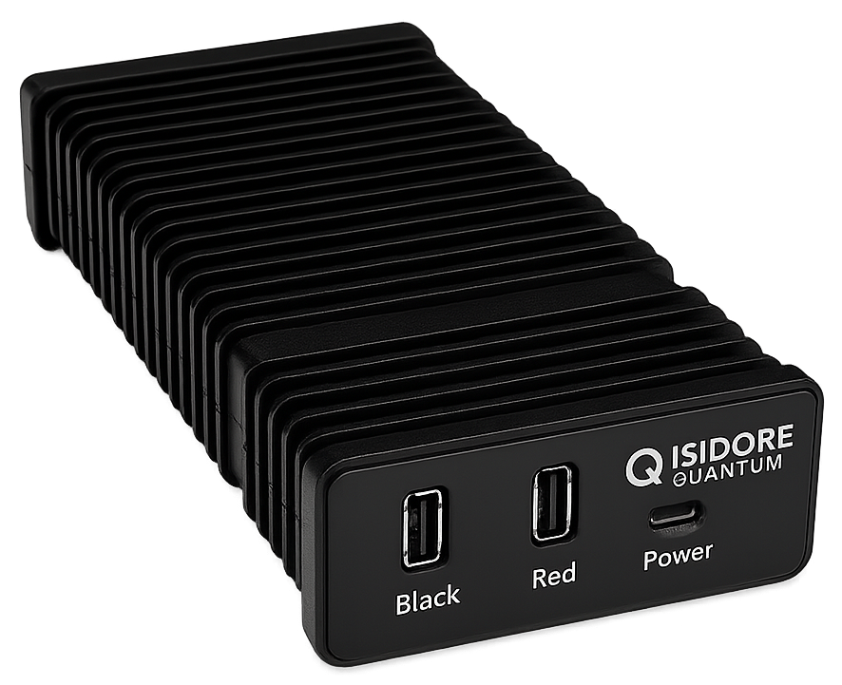
Forward Edge-AI, Inc. has developed Isidore Quantum® technology (pictured below) that provides an immediate, all-in-one cybersecurity and Post-Quantum Cryptography (PQC) solution designed to protect military and government operations from both current and emerging threats. Built on National Security Agency (NSA) Commercial National Security Algorithm (CNSA) 2.0–compliant algorithms, the platform integrates AI-driven anomaly detection, autonomous key management, and zero-trust architecture into a compact, low-power system deployable across tactical, and enterprise environments. Developed with commercial off-the-shelf components and validated through Air Force, Navy, and Space Force testbeds, Isidore Quantum® delivers quantum security at a fraction of the cost and deployment time required by traditional systems.
Proven at TRL 8, the system protects communications, data links, and mission networks without requiring infrastructure redesign, offering a ready-now defense against quantum decryption, cyber intrusion, and command disruption. In an era where speed, affordability, and resilience determine strategic advantage, Isidore Quantum serves as the critical bridge between today’s infrastructure and tomorrow’s quantum-secure force.
U.S. and allied militaries are confronting a rapidly intensifying convergence of cyber warfare and quantum computing that threatens the core of defense C2, and sustainment systems. The Pentagon’s 2025 directives identify quantum decryption as an “existential threat” to secure communications and mission data. RAND analysis warns that once adversarial quantum systems reach full capability, current cryptographic methods could collapse within seconds, exposing classified orders, targeting information, and logistics operations across all domains.
Despite the urgency, many government cybersecurity and acquisition leaders continue to hesitate, postponing action until large defense contractors deliver high-assurance solutions that often arrive years late and at significantly higher cost. Lessons from the war in Ukraine show that future deterrence will rely on rapidly deployable, affordable systems built from commercial off-the-shelf components capable of scaling faster than bureaucratic processes. Delaying for “perfect” solutions developed in laboratories will leave defense networks vulnerable and unprotected when conflict arises.
Capability | Mission Impact
Post-Quantum Encryption (CNSA 2.0) | Protects classified and tactical data from quantum-enabled decryption using ML-KEM, ML-DSA and AES-256 GCM
AI-Driven Cyber Defense | Learns operational “patterns of life,” autonomously detects intrusions, and self-heals without operator input
Zero Trust by Design | Eliminates PKI, certificates, and key loaders—reducing cognitive and logistics burden on operators
Low SWaP-C, TRL-8 | Consumes approximately 8W depending on the variant, built on COTS components, validated across 23 operational testbeds (Air Force, Navy, and Space Force)
CASSIAN Control Plane | Centralized management for real-time visibility, policy enforcement, and algorithm agility across distributed assets.
Red/Black Isolation & Quantum Entropy | Hardware-enforced segmentation + Quantum Random Noise Generation for provably random, one-time keys

- Sponsorship
Our participation in this exercise is sponsored by PACFLT. Isidore Quantum was originally developed under a Phase II Small Business Innovation Research (SBIR) contract for the US Air Force, FA864923P0006 and further developed for US Navy integration under contracts N6833524C0170 (Phase I) and N6833525C0170 (Phase II).
- Logistics
The deployment of Isidore Quantum devices are available for a number of naval use cases including unmanned systems, shipboard and shore applications in support of operations. Each device is approximately 5.5 inches by 3.5 inches by 1.5 inches and weighs about 16oz for easy deployment across multiple platforms. At the conclusion of the exercise, the equipment would be returned to the Forward Edge-AI facility. Forward Edge-AI requests standard 120v outlets/power supply on either side of the communications links.

5. Experiment Implementation
The field team deployed to Valiant Shield 2026 will consist of 2-3 engineers. Forward Ege-AI will bring: 8-port switch(1), Laptops(2),Ethernet cables, and 5-volt PSUs(4).
Deployment Requirements: Participation of at least two operational naval vessels with bridge systems requiring AIS/GPS integration, one port facility for logistics platform testing, and communication gateway radio communication validation.
Observer Requirements: Naval cybersecurity subject matter experts, command staff representatives, maritime logistics personnel, and encryption specialists from the Navy.

